**Project Design Phase-I**

**Solution Architecture**

|  |  |
| --- | --- |
| Date | 4 October 2022 |
| Team ID | PNT2022TMI47681 |
| Project Name | Project – Exploratory Analysis Of Rainfall Data In India For Agriculture |
| Maximum Marks | 4 Marks |

**Solution Architecture:**

Solution architecture is responsible for defining and communicating a shared technical and architectural vision across a “solution train” to help ensure the system solution under development is fit for its intended purposes goals are to

* Find technology solution to business problem that meets business requirements defined by the customer.
* Describe the gist of the solution:it’s structure, and the way it fits with the rest of the business structure and contributes to the workflow.
* Define solution requirements key features of the solution and phases of the implementation.
* Provide specifications for solutions management and delivery.
* Analyse the impact of the solution on the business goals and direct outcomes of solution implementation.

**Example - Solution Architecture Diagram:**

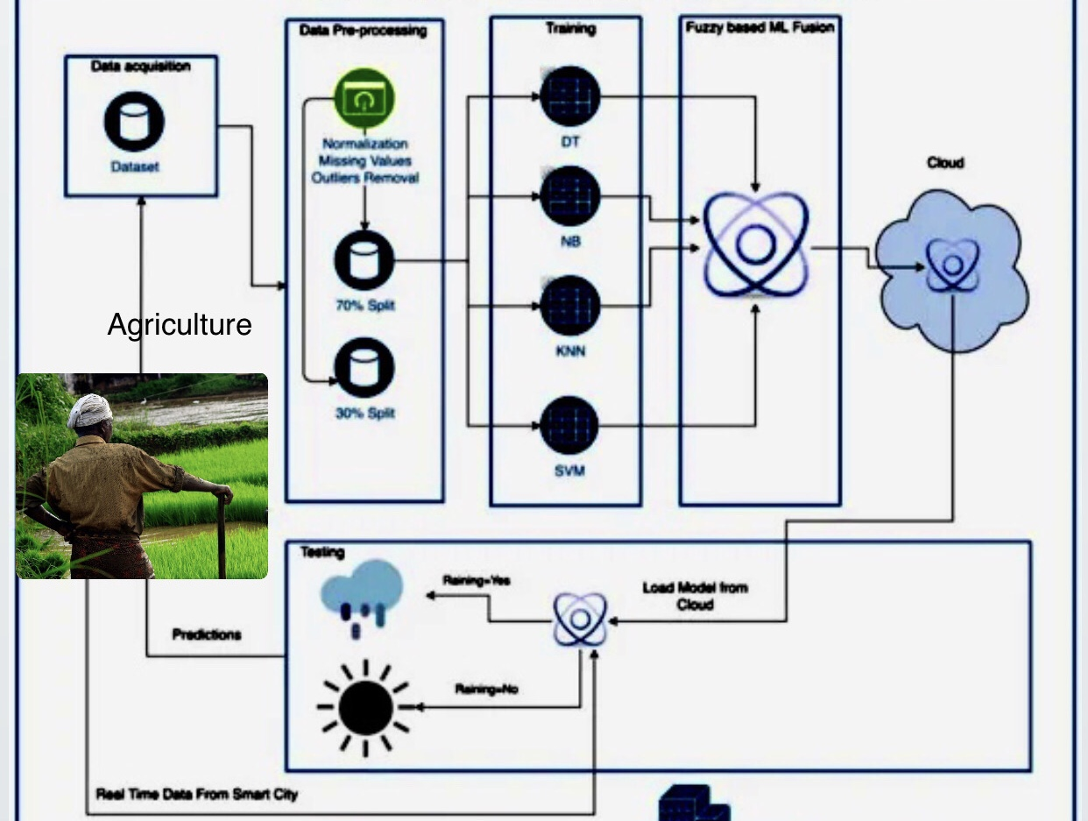

Figure 1: Architecture For Proposed Framework

**Reference:** [**https://www.mdpi.com/1424-8220/22/9/3504/htm**](https://www.mdpi.com/1424-8220/22/9/3504/htm)